CLC Core Competencies Personal Stories and Growth Assignment
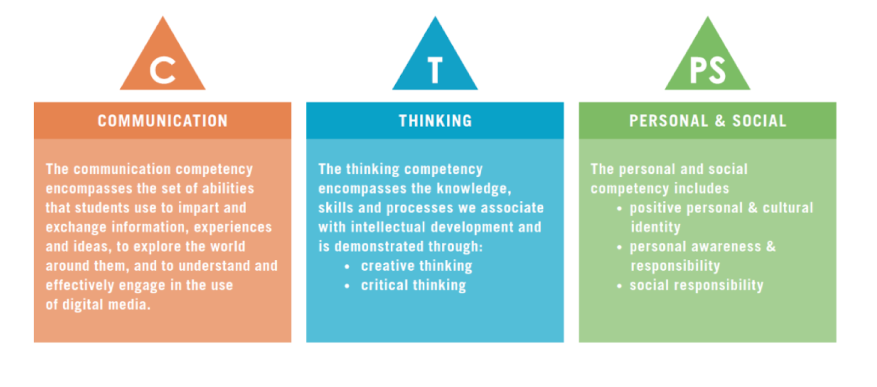
Rationale:
The Core Competencies are skills and abilities that you need in life, for your personal growth, success, and life-long learning. Employers, post-secondaries and scholarship committees ask for evidence of your growth in these core competencies.

Assignment:
Create a story for each of the 3 core competencies that reflect on your high school journey and identify your growth in that area: Communication Skills, Critical/Creative Thinking Skills, Personal/Social Responsibility.

Criteria:
- Use the following page of prompts to help you develop your ideas
- Comment on your level in the core competency in your past. How were you in your Junior years in high school. Reflect on HOW and WHY you were at a certain level
- What is the memorable experience that brought change and growth (what class/person/extra-curricular experience/assignment/personal choice, etc. helped you to grow?) What is the story?
- Look ahead to the future. How do you expect to continue to develop these skills as you progress towards post-secondary?

Evaluation:
- Good copy quality-vocabulary, detailed, edited /2
- Reflection on skill (why/how) /4
- Reason for growth (specific story/explanation) /4

Total /10 per competency

Due Date: _________________________________

