The Body in Motion

Summary: You will complete an original drawing for your final assignment for this unit. Your drawing should explore the movement and motion of the human body. You will demonstrate what you have learned about figure drawing, proportion, movement, and value. You may use reference images to help you draw from, but your final drawing should be an original composition. This means that you are not copying your entire idea from a photograph or from another drawing.

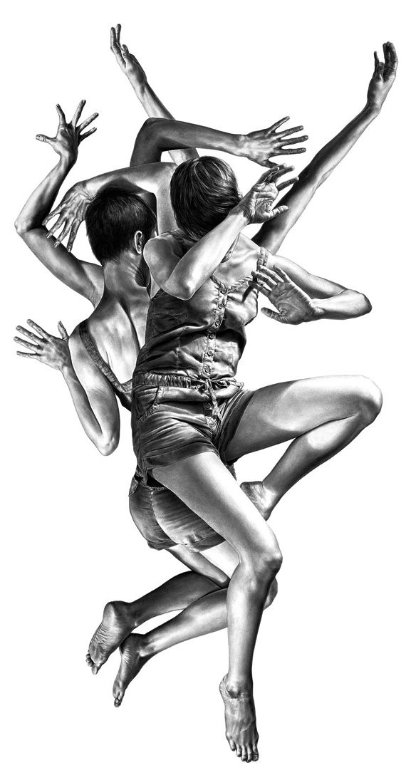
Class Time: You will have approximately 7 full work periods (69 mins each) to complete this drawing. You may also work on this assignment outside of class time.

Medium/Media: You will use chalk pastel, pencil, or coloured pencil (or a combination of these materials) to complete your drawing. If there is another dry medium you are interested in using, please come talk to me!

Subject: Your drawing should feature at least one human figure that is moving. This could be one person or multiple people that are dancing, playing a sport, etc.

Techniques: Apply what you have learned about proportion, figure drawing, movement, and value in your final drawing. Use distortion, repetition, or motion blur to create movement and motion.

Marking: You will receive a mark out of 50 for this drawing. Please refer to the assignment rubric provided for a full breakdown.

