Introduction to Gesture Drawing
Gesture drawing is a way to quickly capture the basic shapes, angles, and attitude of the human form. By working quickly and loosely, you will be able to get a quick “snapshot” of the body in motion.
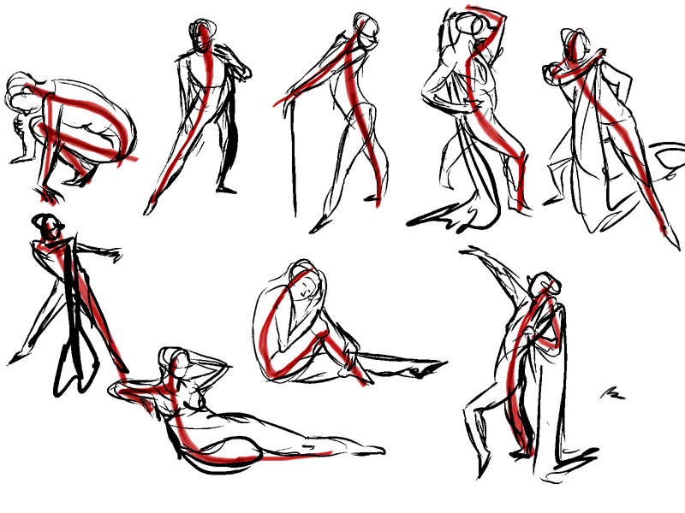 Benoit Therriault
basic Steps:
- Quickly mark the top and bottom of your subject (where is the top of the head and where are the bottoms of the feet?)
- Draw the line of action: The central line or curve that runs down the centre of the subject (their spine). This line shows the general balance or movement of the subject.
- Draw quickly and loosely. Use rough lines and basic shapes to draw the body parts.
- If you have time left, use the side of your drawing tool to add in shadows or start to add more details to the face, hands, and feet.
tips:
- Do not use an eraser! Just keep drawing. Continue drawing overtop of your “mistakes.”
- Work quickly. Don’t focus on drawing the details. Your main goal is to capture the shape and movement of the whole pose.
- Use the tip and the side of your pencil/charcoal to get more line variation.
- Your subject may be moving. Don’t get frustrated. Just keep drawing and try to capture their movement, shapes, and lines.
- Gesture drawings are like “rehearsals.” You are just practicing and recording information. These are not perfect, finished drawings.

